

**Ref Splash Screen On First Open Our App Splash SS**

**User App OTP based Login rahega**

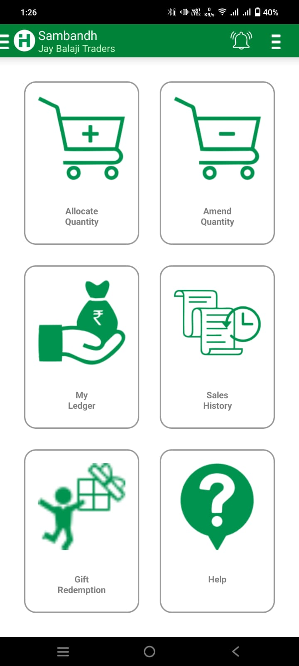

**Ref App Homepage**

**Options We Need**

* **View Points**
* **Product Redeem History**
* **Points Report**

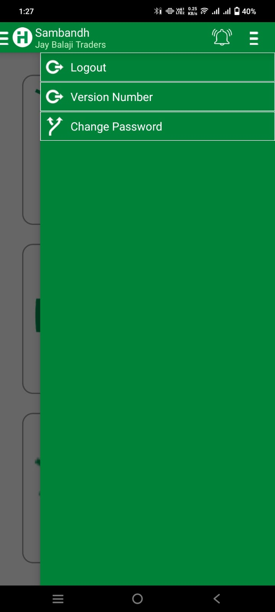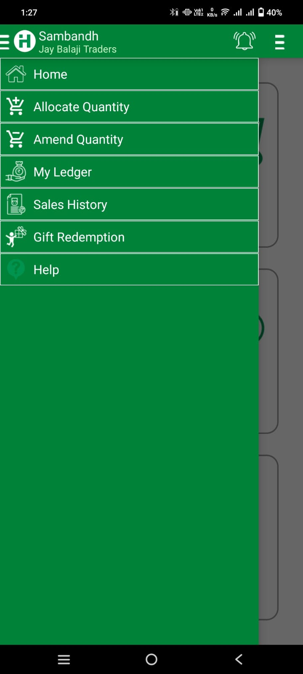

**Ye Ref App Ka Left and right side bar haihamebhiaisachaiye niche image me design hai**

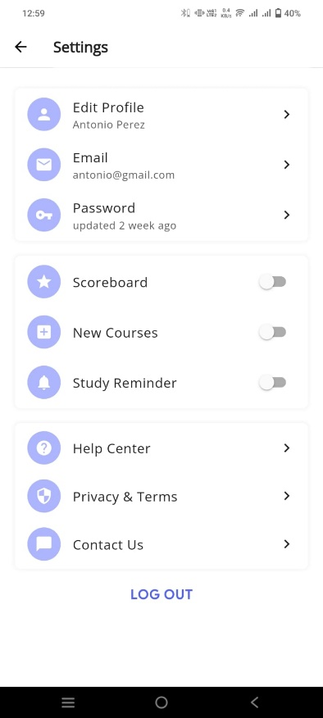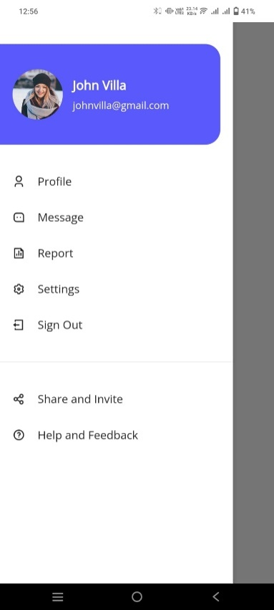Hameaisa design chaiye upper same profile image name email or number then niche ye tabs

**Left Side Bar**

* **View Points**
* **Product Redeem History**
* **Points Report**

**Right Side Bar**

* **Edit Profile**
* **Logout**

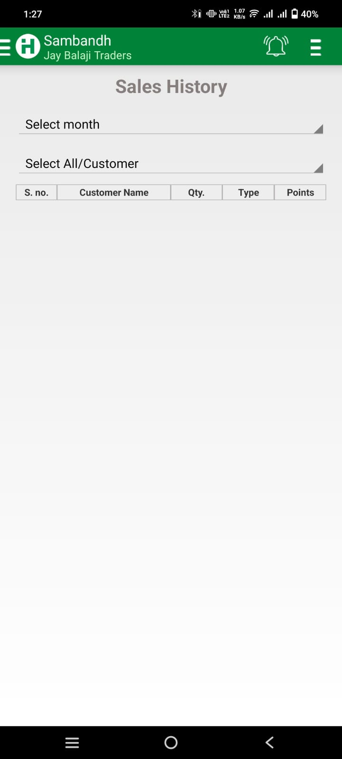

**Points Sales history hamare app me points history hai date select par chaiye + today, yesterday, this week, this month, this year ye sab**

**Table me ye sab**

* **S.no**
* **Type me - + add or deduct**
* **Points me kitne points add huyaya - huya**